Assessment Schedule – 2016
Physics: Demonstrate understanding of aspects of electricity and magnetism (90937)
Evidence Statement
Question | Evidence | Achievement | Merit | Excellence
ONE  (a) | Electrical conductors are materials that have electrons (or negative charges) that are free to move through it. Electrical insulators are materials where electrons are not free to move easily through, as they are tightly bound to the atoms. | Describes conductors and insulators with reference to the motion of electrons (or negative charges).
(b) | Aluminium pans are good electrical conductors. When they are in contact with the control tube, they all become positively charged by losing electrons. Since they are now all the same charge, they repel away from each other. | Describes how like charges repel. | Explains how the pans become positively charged by losing electrons and links that to repulsion of like charges.
(c)(i)  (ii) | See diagrams in Appendix.  Upon initial contact, there is a transfer of electrons to the plate and the metal bead is now positively charged and repelled away from the positive plate 2.  Plate 1 is neutral and grounded by the finger. When the + charged bead approaches it and makes contact, the metal bead is then earthed (gains electrons) and is neutral once again. | Describes any one step of the metal beads process. E.g. when it touches the positive Plate 2, the metal bead becomes positively charged and is repelled away. | Explains the motion of the metal bead between BOTH plates (understands the two different processes occurring on each plate – one is charging by contact and one is earthing the metal bead). | Full understanding shown of the motion of the metal bead between BOTH plates, including correct diagrams of charge distribution at each stage, and motion of electrons explained during contact between each plate and metal bead.
(d) | 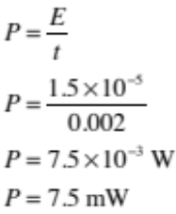 | Correct substitution but answer not expressed correctly in mW. | Correct power calculation and expressed in mW.

NØ | N1 | N2 | A3 | A4 | M5 | M6 | E7 | E8
No relevant evidence. | Very little evidence at the Achievement level. Most evidence is at the Not Achieved level. | Some evidence at the Achievement level; partial explanations. | Most evidence provided is at the Achievement level, while some is at the Not Achieved level. | Nearly all evidence provided is at the Achievement level. | Some evidence is at the Merit level with some at the Achievement level. | Most evidence is at the Merit level, with some at the Achievement level. | Evidence is provided for most tasks, with evidence at the Excellence level weak or with minor errors / omissions. | Evidence provided for all tasks. Evidence at the Excellence level accurate and full.
0 | 1A | 2A | 3A | 4A | 1A + 2M | 2A + 2M | 2M + 1E | 1A + 2M + 1E

Question |  | Achievement | Merit | Excellence
TWO  (a)(i)  (ii) | Parallel.  As there is more than one closed pathway in the circuit, if one bulb were to stop working, the others would still work. OR Bulbs have maximum brightness / known voltage. | Recognises a parallel circuit AND gives a valid advantage of a parallel circuit.
(b)(i)  (ii) | Calculation:  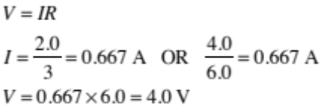  OR  Reasons that each branch receives 4.0 V in a parallel circuit.  Power used by bulb B in parallel circuit:  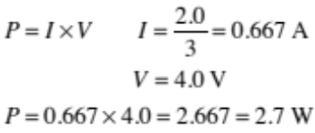 | Correct calculation or valid reason for voltage. | Current and voltage correctly identified for a parallel circuit and used to calculate power.
(c)(i)  (ii) | 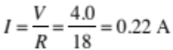  Circuit diagram in Appendix. | Correct current.  AND  Series circuit diagram with minor errors.  All 3 bulbs connected in series. | Correct current calculation and series circuit diagram with meters connected correctly.
(d) | Power used by bulb B in series circuit:  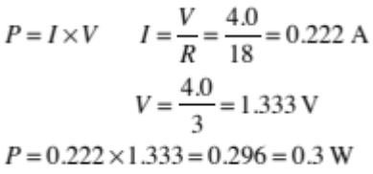  Power used by bulb B is now significantly reduced in the series circuit (th the value). This is due to two reasons:  - Voltage across bulb B is now less, as the total 4 V is shared across all three bulbs  - Current is also reduced (from 0.67 A to 0.22 A), as the circuit now has more resistance when the bulbs are connected in series.  As power is the product of current × voltage, as both current and voltage have reduced, so has the power. | Correctly identifies the current OR voltage of bulb B.  OR  States the power is now reduced in the series circuit. | Correct use of formula for power but uses incorrect current OR voltage of bulb B (must have found at least one of the current or voltage values).  OR  Explains ONE reason why the power used by bulb B is now less in the series circuit. | Comparison of power of bulb B between the two circuits, which includes correct calculation AND reasons refer to both current and voltage changes in the series circuit.

NØ | N1 | N2 | A3 | A4 | M5 | M6 | E7 | E8
No relevant evidence. | Very little evidence at the Achievement level. Most evidence is at the Not Achieved level. | Some evidence at the Achievement level; partial explanations. | Most evidence provided is at the Achievement level, while some is at the Not Achieved level. | Nearly all evidence provided is at the Achievement level. | Some evidence is at the Merit level with some at the Achievement level. | Most evidence is at the Merit level, with some at the Achievement level. | Evidence is provided for most tasks, with evidence at the Excellence level weak or with minor errors / omissions. | Evidence provided for all tasks. Evidence at the Excellence level accurate and full.
0 | 1A | 2A | 3A | 4A | 1A + 2M | 2A + 2M | 2M + 1E | 1A + 2M + 1E

Question | Evidence | Achievement | Merit | Excellence
THREE  (a) | 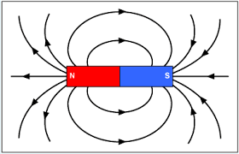 | Correct diagram with a symmetrical shape and direction.
(b) | The strength of the magnetic field is stronger at the poles of the magnet and weaker above and below the halfway point of the magnet (or as you move further away from the magnet).  The field lines show the strength of the magnetic field by their proximity. The closer they are together, the stronger the magnetic field, and vice versa. | Description of a changing magnetic field strength around a bar magnet. | Explains how the magnetic field strength changes and how areas of a strong field and a weak field are represented by the field lines.
(c) | 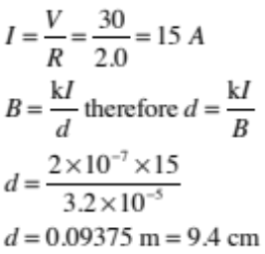 | Correct calculation of current of 15 A. | Correct calculation of current and distance, and distance expressed in cm.
(d)(i)  (ii) | For repulsion to occur, the end closest to the bar magnet must be a north pole as well (as like poles repel). Therefore, using the Right Hand Grip Rule (or Left Hand GR for e flow) the current must be flowing down the sections of wire of the coil shown in the diagram.  As they are both the same strength and have two north poles facing each other, at the halfway point, the magnetic field due to the electromagnet is equal and opposite to the magnetic field due to the magnet, so the two fields cancel out and the net effect will not affect the compass needle. This means that the compass will align with the Earth’s magnetic field, so will point to the magnetic south pole (acceptable geographic north). | Recognises the end of the electromagnet must be a north pole.  OR  Recognises magnetic field caused by the two objects will not affect the needle. | Explains that the end of the electromagnet must be a north pole, as like poles repel.  OR  Explains why the magnetic field caused by the two objects does not affect the needle because they are equal and opposite. | Current drawn correctly and complete explanation involving polarity and use of Right Hand Grip Rule to determine direction of current.  AND  Full answer that links the compass being influenced only by Earth’s magnetic field and not that of the two magnetic objects.

NØ | N1 | N2 | A3 | A4 | M5 | M6 | E7 | E8
No relevant evidence. | Very little evidence at the Achievement level. Most evidence is at the Not Achieved level. | Some evidence at the Achievement level; partial explanations. | Most evidence provided is at the Achievement level, while some is at the Not Achieved level. | Nearly all evidence provided is at the Achievement level. | Some evidence is at the Merit level with some at the Achievement level. | Most evidence is at the Merit level, with some at the Achievement level. | Evidence is provided for most tasks, with evidence at the Excellence level weak or with minor errors / omissions. | Evidence provided for all tasks. Evidence at the Excellence level accurate and full.
0 | 1A | 2A | 3A | 4A | 1A + 2M | 2A + 2M | 2M + 1E | 1A + 2M + 1E

Cut Scores
Not Achieved | Achievement | Achievement with Merit | Achievement with Excellence
0 – 6 | 7 – 12 | 13 – 19 | 20 – 24

Appendix of Diagrams

Question One (c) (i)
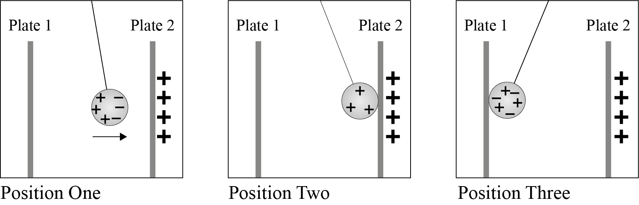

Question Two (c)

